Temperature, Rainfall, and Biome Distribution Lab

In this lab you will investigate the relationship between the amount of rainfall and the variance of temperature and how these two variables influence biomes. Biomes are defined as the world's major communities, classified according to the predominant vegetation and characterized by adaptations of organisms to that particular environment. If you do not know anything about biomes, before starting this lab you should spend some time reading over the following website: http://www.thewildclassroom.com/biomes/index.html . We have included below some additional baseline information you should read before completing this lab assignment.

Assignment Objectives:

- To develop an understanding of the biomes of the world.
- To examine central concepts of physical geography from a spatial perspective by creating and interpreting maps and graphics.
- To communicate physical processes using maps and graphics.
- To explain patterns in the physical environment using spatially informed logic.
- To explore the biome in which you live.

Assignment Specifics:

This lab assignment is divided into three sections. Section I provides a brief review of biomes. In Section II you will explore the use of climatographs to understand the differences and similarities between biomes. In Section III, you will review the basic plant adaptations to the biomes of the world and take a closer look at plant adaptations here in Southern California. By the end of this lab, you should have an understanding of where the biomes of the world are located, what they are, and how they are similar and different.

Turn In:

The attached lab assignment with the 3 climographs filled in and all questions answered.
A Brief Review of Biomes

What is a biome?
A biome is a large geographical area of distinctive plant and animal groups, which are adapted to that particular environment. The climate and geography of a region determines what type of biome can exist in that region. Few geographers agree on exactly how many biomes exist, this is in large part determined by the scale of your research. However, most agree that there are at least 7 major biomes including rainforest, grassland, temperate forests, desert, chaparral (Mediterranean scrub), tundra, and taiga. Each biome consists of many ecosystems whose communities have adapted to the differences in climate and the environment inside the biome.

To understand a world biome, you need to know:
- What the climate of the region is like.
- Where each biome is found and what its geography is like.
- The special adaptations of the vegetation.
- The types of animals found in the biome and their physical and behavioral adaptations to their environment.

Attached below is a map showing the distribution of these 7 major biomes. If you were to look at a world map of precipitation and temperature, you find both of these maps closely correlate with the biome map below. To find out more about biomes, please go to http://www.thewildclassroom.com/biomes/index.html . On this website, you will find descriptions of each of the biomes. A word of caution, this website is slightly different than the map included in this lab. That is okay, it will give you a sense of how biomes are categorized. On this website, temperate forests are called “deciduous forests”, savannahs are separated into their own category (savannahs are lumped into the “grassland biome” in the map below), and desert scrub is separated out from the “desert” biome. Take some time to explore this website and educate yourself a little about biomes before moving on to the next section!
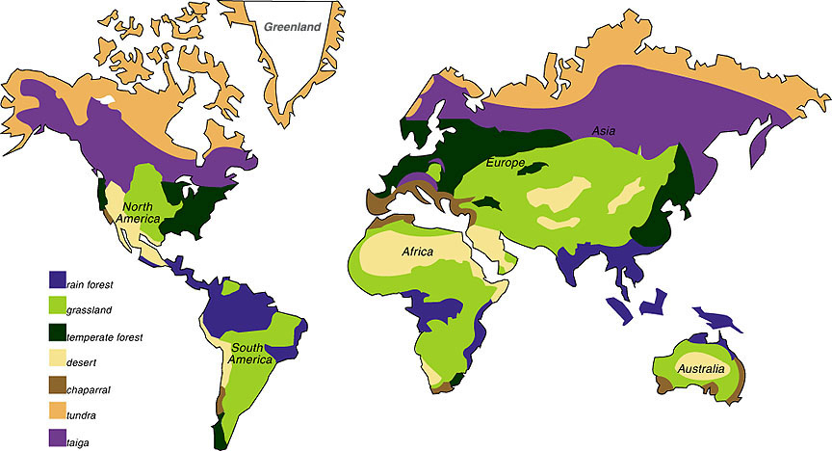

Figure 1. Seven major biomes of the world.
Working with Climatographs

You will find below five examples of climatograph grids on which averages of precipitation and temperature at a particular location are plotted together. These climatographs show variations in only two important climatic factors during a year. Other factors may greatly affect climate, but a climatograph does give a rough idea of climate in the location from which the data were obtained.

Biomes are closely associated with climate. You can easily associate the climate of your own locality with the biome found there. Only by extensive travel, however, can the close relationship of particular climates with particular biomes be learned on a worldwide basis. This exercise is a poor substitute for such travel; but if it is carried out thoughtfully and with frequent reference to the description of biomes in the above website or your textbook, it can help you understand the biological relationships that make up the diversity of the biotic communities found on land.

Purpose:
This exercise provides practice in associating climate (as expressed in monthly averages of precipitation and temperature) with biomes. You will also make predictions about the distribution of a biome via altitude and latitude.

Procedure:

- First, you will see attached on the following pages a series of climatographs. The last set of three climatographs are blank. Next to each is a table with data. Fill in the climatographs for each of the four blank graphs.
- When finished, you will have 8 climatographs, 7 of which represent the biomes found worldwide. One, is a mystery climograph…more on this later. We have also included a map showing the location of each of the cities used for the climatographs. When you are done filling in the last three climatographs, you can then proceed to the next set of instructions.

CLIMATOGRAPHS
Below are a series of climographs. The blue bars represent precipitation (mm), the red lines represent temperature (⁰C). Review each of these and then fill in the last three on your own with the given data.

Tundra (Barrow, Alaska)
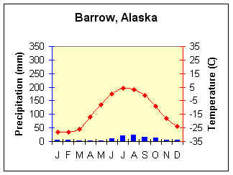

Taiga (Yakutsk, Russia)
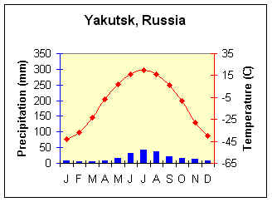

Temperate Forest (Memphis, Tennessee)
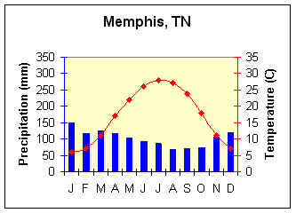

Tropical Rainforest (Iquitos, Peru)
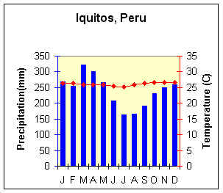

Middle latitude desert (Yuma, AZ)
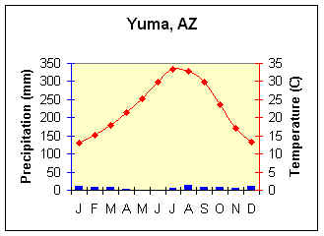

 | 350 |  |  |  |  |  |  |  |  |  |  |  |  |  |  |  |  |  |  |  |  |  |  |  | 20
 | 300 |  |  |  |  |  |  |  |  |  |  |  |  |  |  |  |  |  |  |  |  |  |  |  | 15
 | 250 |  |  |  |  |  |  |  |  |  |  |  |  |  |  |  |  |  |  |  |  |  |  |  | 10
Precipitation (mm) | 200 |  |  |  |  |  |  |  |  |  |  |  |  |  |  |  |  |  |  |  |  |  |  |  | 5 |  | Temperature (⁰C)
Precipitation (mm) | 150 |  |  |  |  |  |  |  |  |  |  |  |  |  |  |  |  |  |  |  |  |  |  |  | 0
 | 100 |  |  |  |  |  |  |  |  |  |  |  |  |  |  |  |  |  |  |  |  |  |  |  | -5
 | 50 |  |  |  |  |  |  |  |  |  |  |  |  |  |  |  |  |  |  |  |  |  |  |  | -10
 | 0 |  |  |  |  |  |  |  |  |  |  |  |  |  |  |  |  |  |  |  |  |  |  |  | -15
 |  | J |  | F |  | M |  | A |  | M |  | J |  | J |  | A |  | S |  | O |  | N | D
 | Month
Grassland (Bismarck, North Dakota)
 |  |  | Jan |  | Feb |  | Mar |  | Apr |  | May |  | Jun |  | Jul |  | Aug |  | Sep |  | Oct |  |  | Nov |  | Dec
Avg. Precip (mm) |  |  | 11.4 |  | 13 |  | 21.6 |  | 37.1 |  | 56.4 |  | 65.8 |  | 65.5 |  | 54.6 |  | 40.9 |  | 32.5 |  |  | 17.8 |  | 11.2
Avg. Temp (⁰C) |  |  | -12.1 |  | -7.7 |  | -1.3 |  | 6.3 |  | 13.3 |  | 18.2 |  | 21.3 |  | 20.6 |  | 14.3 |  | 7.3 |  |  | -2.2 |  | -9.3

 | 350 |  |  |  |  |  |  |  |  |  |  |  |  | 20
 | 300 |  |  |  |  |  |  |  |  |  |  |  |  | 15
 | 250 |  |  |  |  |  |  |  |  |  |  |  |  | 10
Precipitation (mm) | 200 |  |  |  |  |  |  |  |  |  |  |  |  | 5 | Temperature (⁰C)
Precipitation (mm) | 150 |  |  |  |  |  |  |  |  |  |  |  |  | 0 | Temperature (⁰C)
 | 100 |  |  |  |  |  |  |  |  |  |  |  |  | -5
 | 50 |  |  |  |  |  |  |  |  |  |  |  |  | -10
 | 0 |  |  |  |  |  |  |  |  |  |  |  |  | -15
 |  | J | F | M | A | M | J | J | A | S | O | N | D
 | Month

Mediterranean Scrub (San Francisco, CA)
 | Jan | Feb | Mar | Apr | May | Jun | Jul | Aug | Sep | Oct | Nov | Dec
Avg. Precip (mm) | 113 | 101.9 | 82.8 | 30 | 9.7 | 2.8 | 0.8 | 1.8 | 5.1 | 26.4 | 63.2 | 73.4
Avg. Temp (⁰C) | 9.7 | 11.3 | 12.2 | 13.4 | 14.8 | 16.3 | 17.1 | 17.6 | 17.7 | 16.1 | 12.6 | 9.7

 | 350 |  |  |  |  |  |  |  |  |  |  |  |  | 20
 | 300 |  |  |  |  |  |  |  |  |  |  |  |  | 15
 | 250 |  |  |  |  |  |  |  |  |  |  |  |  | 10
Precipitation (mm) | 200 |  |  |  |  |  |  |  |  |  |  |  |  | 5 | Temperature (⁰C)
Precipitation (mm) | 150 |  |  |  |  |  |  |  |  |  |  |  |  | 0 | Temperature (⁰C)
 | 100 |  |  |  |  |  |  |  |  |  |  |  |  | -5
 | 50 |  |  |  |  |  |  |  |  |  |  |  |  | -10
 | 0 |  |  |  |  |  |  |  |  |  |  |  |  | -15
 |  | J | F | M | A | M | J | J | A | S | O | N | D
 | Month

Mystery Biome
 | Jan | Feb | Mar | Apr | May | Jun | Jul | Aug | Sep | Oct | Nov | Dec
Avg. Precip (mm) | 75.7 | 79 | 61 | 16 | 6.1 | 2 | 0.8 | 3.6 | 6.6 | 9.1 | 28.7 | 45.5
Avg. Temp (⁰C) | 13.9 | 14.4 | 14.6 | 16 | 17.3 | 19.1 | 20.7 | 21.5 | 21.2 | 19.4 | 16.4 | 14.2

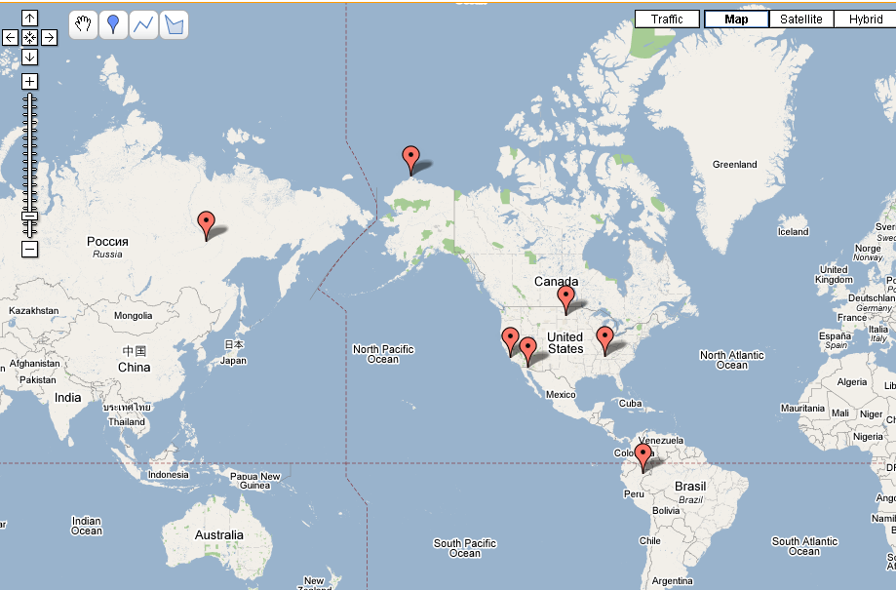
Bismarck, ND
Memphis, TN
San Francisco, CA
Yuma, AZ
Barrow, AK
Yakutsk, Russia
©2007 Google – Map Data ©2007 Europa Technologies
Iquitos, Peru
Now, answer the following questions:

- Which of the known biome climographs closely resembles San Francisco?

  - In what ways were they similar?

  - In what ways were they different?

  - Would you consider them to truly be the same biome? Explain?

  - During the thirty year period used for the figures in the San Francisco climograph there were four drought periods. How would this effect the appearance of the climograph?

- How are the Tundra and Desert similar? Different? Explain why the are the same and different.
  - Similar
  - Different

- How are the Tropical Rain and Tropical Deciduous Forests similar? different?
  - Similar
  - Different

- San Francisco, CA and Nashville, TN occupy similar latitudes (San Francisco is slightly higher in latitude). Why is one found in chapparal (Mediterranean) biome and the other in a forest biome?

- Which biome has the:
  - most rainfall
  - least rainfall
  - the highest average temperature
  - the lowest average temperature
  - most consistent year round temperature
  - most variable year round temperature

- Take a guess as to what biome the mystery biome belongs to! Please explain why you think this is the case.

